  - Imagination
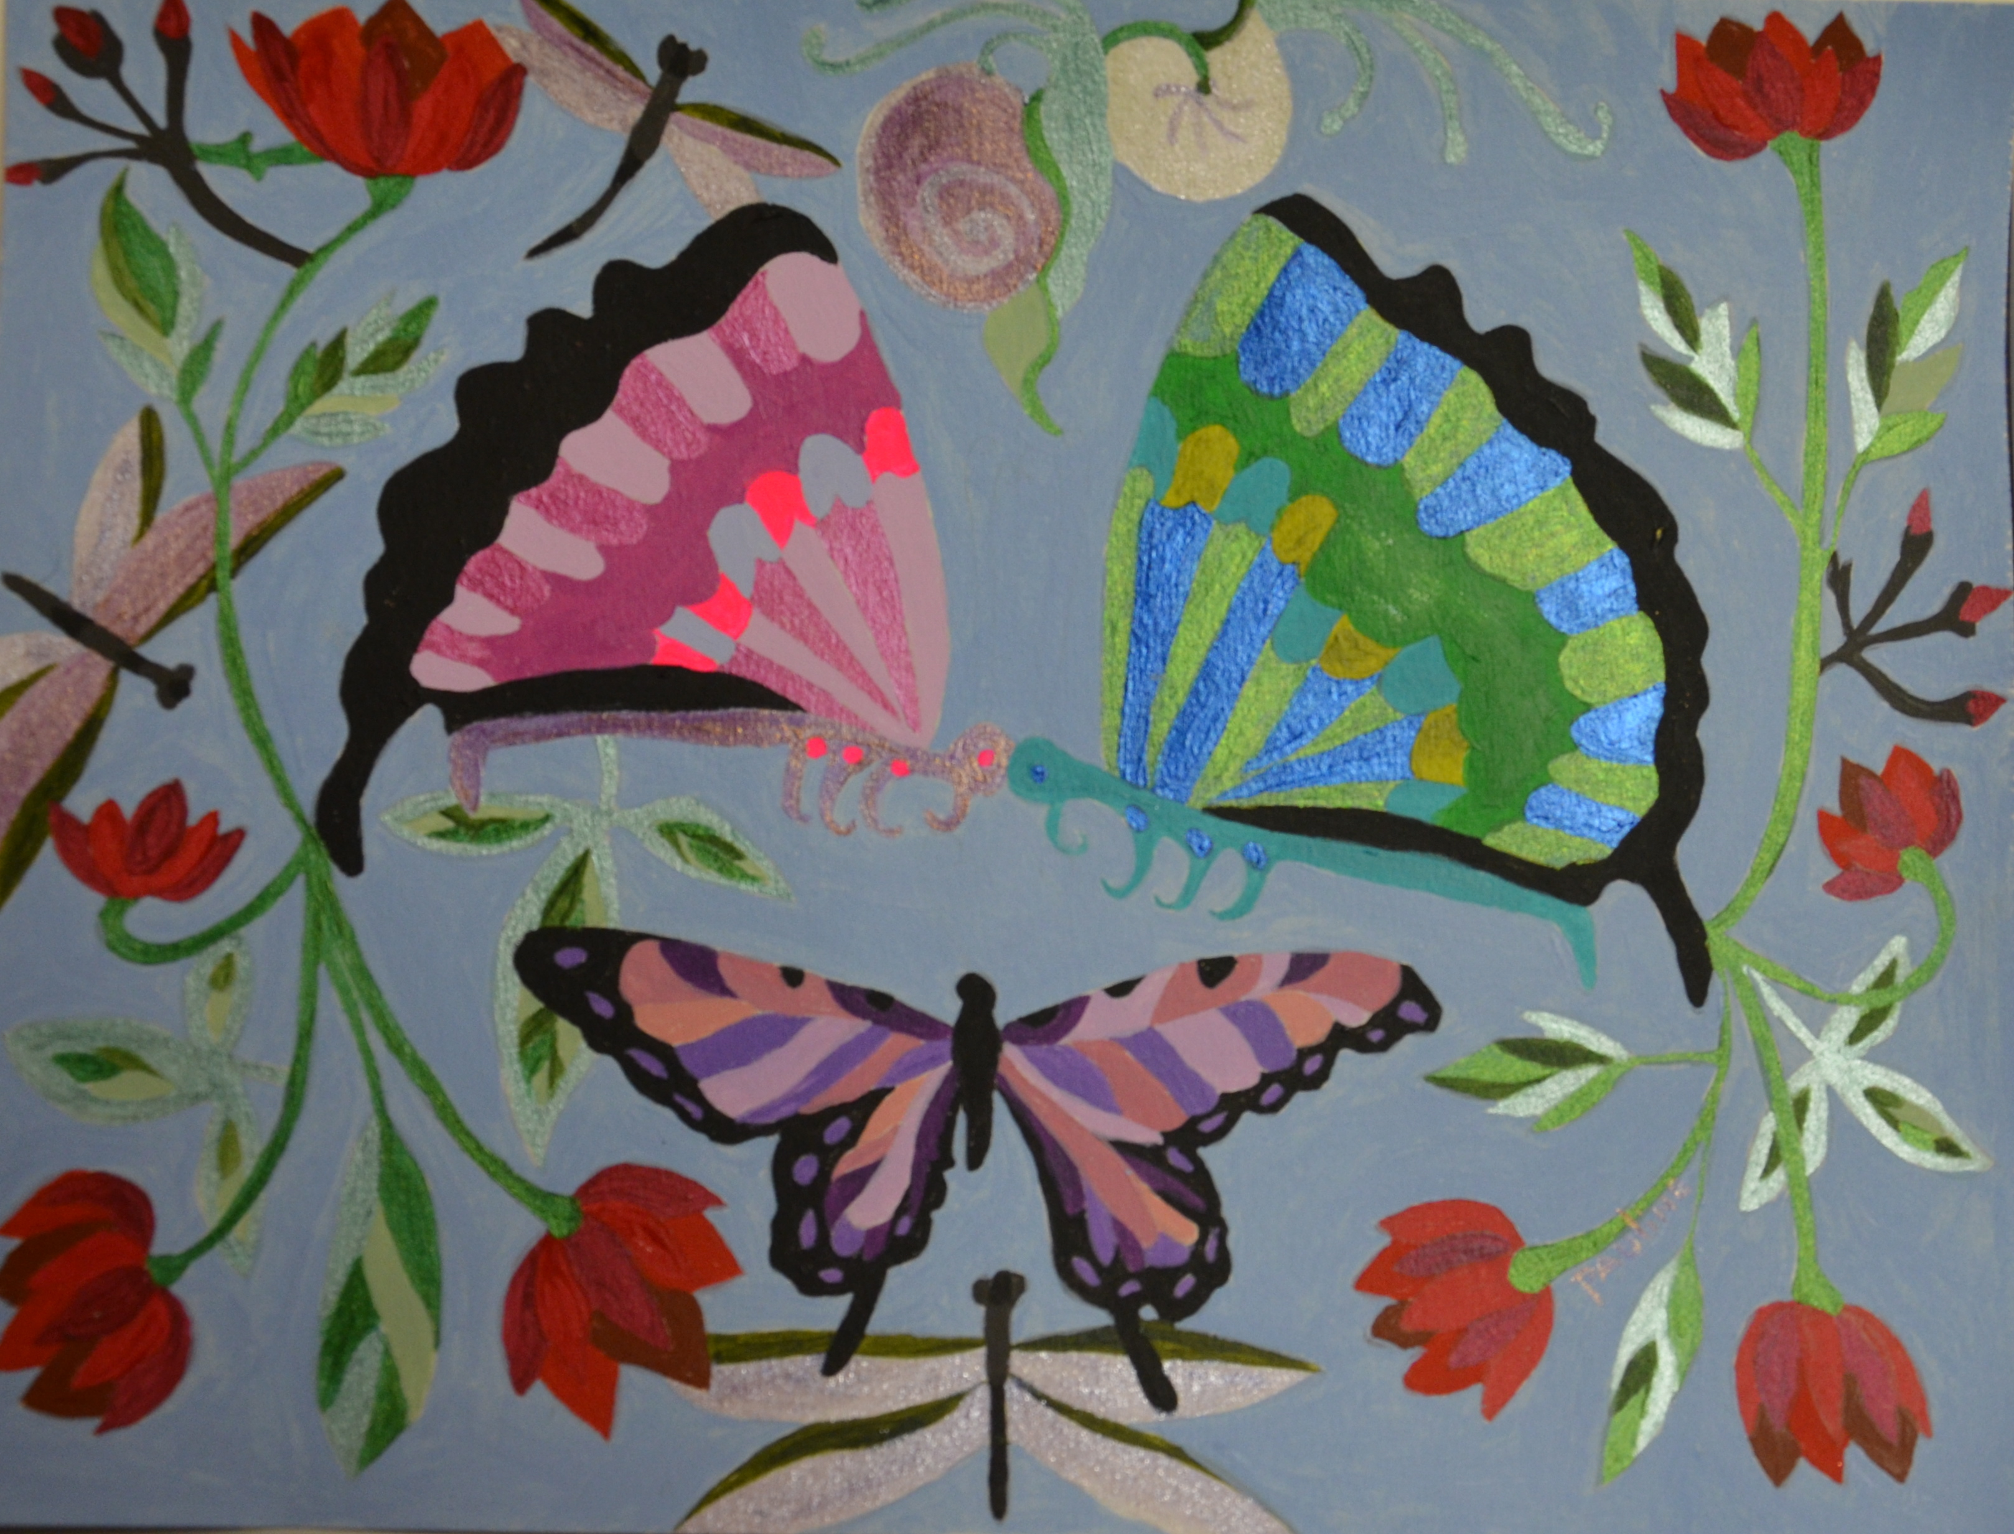
Told through Shutter and Brush

Robin D’Antona & Pauline Finberg

Opening Reception

Sunday

December 7, 2014

2PM-6PM

Cutter Gallery

Rte. 60 & Massachusetts Ave.

Arlington, MA 02474

Photos & Paintings will be on display from

12/7/14 to 1/29/15

Artists will be present: 12/9 2-5PM: 12/20 11:AM-3PM; 1/6 10AM-12PM;

1/13 -2-5PM; Closing 1/29/15- 3-5PM

